Fixed-mount Optical splice box/optical patch panel with up to 96 fibers
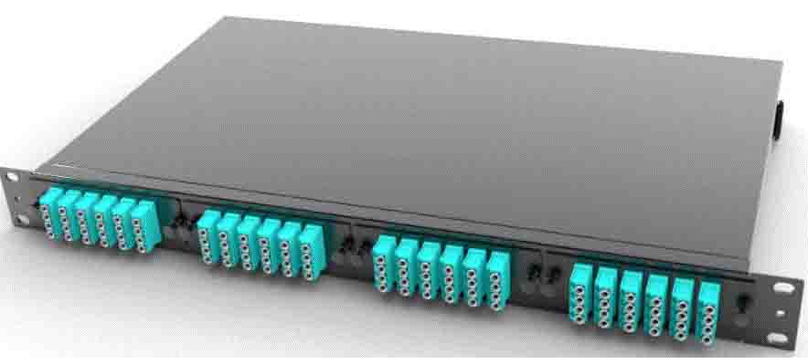
Features
The 1U fixed splice box/optical patch panel defines new standards for professional fiber optic distribution. With up to 96 fibers in just one rack unit, it offers the highest port density on the market for space-critical applications in data centers, telecommunications infrastructure and enterprise networks.
Modular design, with 4slot, each slot accommodates 24core LC/12core SC
Up to 96 fibers in just 1U (44mm) – record port density
Permanently mounted construction for lasting stability
47% more capacity than conventional 1U solutions
Front-access design for maintenance-friendly installation
LC, SC, E2000 and MPO/MTP connector variants available
Pull-out cassettes with precise fiber guidance
19″ rack-compatible with standard fasteners
Suitable for G.657.A1/A2, G.652, OM1/OM2/OM3/OM4/OM5 multimode etc fiber

Main parameters:
Max capacity: 96core LC/48core SC
Size: 482*220*44mm
Weight: 2.6kgs
Slot: 4
Thickness: 1.3mm
Material: cold-rolled sheet
Color: Black, other colors available

