The Difference Between OM1,OM2,OM3 and OM4 Multimode Fibers
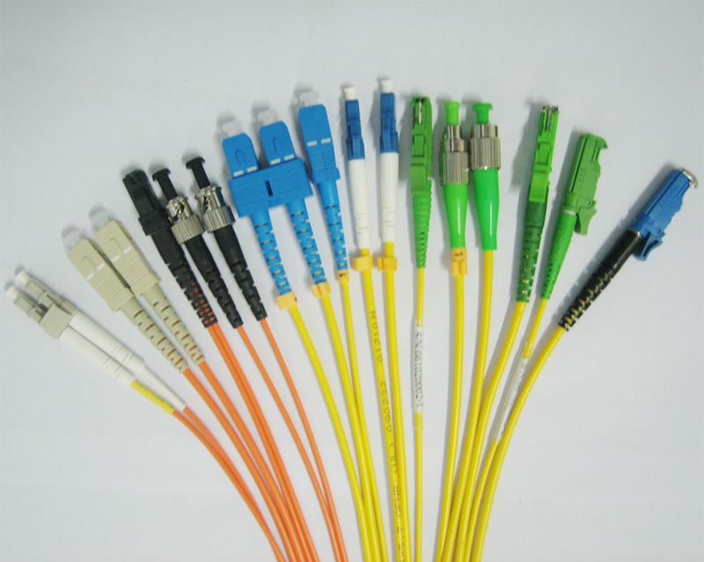
The demand for higher speeds in the enterprise network is rapidly increasing. This is due to the massive amount of storage that’s needed for things such as videos like this. That means there needs to be quick access to this large amount of data – and that’s done by cabling.
We’re going to talk about the OM1, OM2, OM3 and OM4 fiber cabling today. The OM stands for optical multi-mode. The differences between the following OM fiber can aid in your decision making process.

OM1
- Color – Orange
- Core Size – 62.5um
- Data Rate – 1GB @ 850nm
- Distance – Up to 300 meters
- Applications – Short-Haul Networks, Local Area Networks (LANs) & Private Networks
OM2
- Color – Orange
- Core Size – 50um
- Data Rate – 1GB @ 850nm
- Distance – Up to 600 meters
- ◦Generally used for shorter distances
- ◦2x Distance Capacity of OM1
- Applications – Short-Haul Networks, Local Area Networks (LANs) & Private Networks
OM3 – Laser-Optimized Multimode
- Color – Aqua
- Core Size – 50um
- Date Rate – 10GB @ 850nm
- Distance – Up to 300 meters
- ◦Uses fewer modes of light, enabling increased speeds
- ◦Able to run 40GB or 100GB up to 100 meters utilizing a MPO connector
- Applications – Larger Private Networks
OM4 – Laser-Optimized Multimode
- Color – Aqua
- Core Size – 50um
- Data Rate – 10GB @ 850nm
- Distance – Up to 550 meters
- ◦Able to run 100GB up to 150 meters utilizing a MPO connector
- Applications – High-Speed Networks – Data Centers, Financial Centers & Corporate Campuses

How to Choose The Right Fiber Optic Cable Type?
Item | Fiber Dia(um) | Fiber type | Fast Ethernet 100Base-Fx | 1G Ethernet 1000Base-Sx | 1G Ethernet 1000Base-Lx | 10G Ethernet 10Base | 40G Ethernet  40GBASE-SR4 | 100G Ethernet  100GBASE-SR4
OM1 | 62.5/125 | Multimode | 2000 Meters | 275meters | 550 Meters  (mode conditioning patch cable required) | 33meters | Not support | Not support
OM2 | 50/125 | Multimode |  | 550Meters |  | 82meters | Not support | Not support
OM3 (Laser Optimized) | 50/125 | Multimode |  |  |  | 300meters | 100meters | 100meters
OM4 (Laser Optimized) | 50/125 | Multimode |  |  | 550 Meters | 400meters | 150meters | 150meters
Singlemode | 9/125 | Singlemode |  | 550Meters | 20km at 1310nm,120km at 1550nm | 20km at 1310nm,80km at 1550nm | Not support | Not support

PS: The difference of OM4 and OM3 fiber mode as the following
1. OM4 was developed specifically for VSCEL laser transmission and allows 10 Gig / second link distances of up to 550 Meters (compared to 300M with OM3).
2. The effective modal bandwidth for OM4 is more than double that of OM3.
3. For OM4 patch cable, it is 4700 MHz.km while for OM3, it is 2000 MHz.km.
- Choosing the right fiber type for your application is important. Future proofing your network design is crucial for network planning, but there is often a cost for that speed. So plan well and spend wisely.

Any question, please don’t hesitate to contact us. Email: sales@htopto.com

