Fiber Optic Innovator
100Ghz Dense Wavelength Division Multiplexer (DWDM)

Features
Low Insertion Loss High Channel Isolation
High stability and reliability
Epoxy Free Optical Path
Application
DWDM Network Wavelength Routing Fiber Optical Amplifier CATV Fiberoptic System

Specifications

Parameter |  | 1x2 100Ghz DWDM
Channel Wavelength (nm) |  | 1529.55~1561.42 (ITU 20~ 60)
Center Wavelength Accuracy (nm) |  | ± 0.05
Channel Passband (@-0.5dB bandwidth) (nm) |  | > 0.22
Insertion Loss (dB) | Add / Drop Ch. | < 1.0
 | Express Ch. | < 0.4
Channel Ripple (dB) |  | < 0.4
Isolation(dB) | Adjacent Ch | > 25
 | Non-adjacent Ch | > 35
Express Channel Isolation (dB) |  | > 10
Insertion Loss Temperature Sensitivity (dB/°C ) |  | < 0.003
Wavelength Temperature Shifting (nm/°C ) |  | < 0.002
Polarization Dependent Loss (dB) |  | ≤ 0.10
Polarization Mode Dispersion (ps) |  | ≤ 0.1
Directivity (dB) |  | ≥ 50
Return Loss (dB) |  | ≥45
Power Handling (mW) |  | ≤300
Operating Temperature (°C) |  | 0 ~ +70
Storage Temperature (°C) |  | -40 ~ +85
Package Dimension (mm) |  | Ø5.5 x L35

Tel: +86 755 86197637 www.htopto.com sales@htopto.com

Fiber Optic Innovator

Package Dimensions:
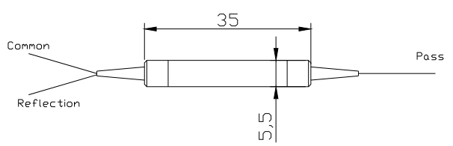

Ordering Information:

DWDM | Channel  Type | Spacing | ITU  Channel | Pigtail Type | Fiber  Type | Length | Connector
 | 1=1ch | 1=100Gh  z | 21=21ch  22=22ch  ……  60=60ch | 250=250um bare fiber 900=900um loose  tube  2000=2mm loose tube 3000=3mm loose tube | 1=SMF-  28e | 1= 1m X=Spec ify | NE=None FA=FC/APC FC=FC/UPC SA=SC/APC SC=SC/UPC LC=LC/UPC LA=LC/APC XX=Other

Tel: +86 755 86197637 www.htopto.com sales@htopto.com

