Fiber Optic Innovator _

50GHz DWDM Filter
_________________ Fiber Optic Innovator
_
Features

Applications

High Demux Channel Isolation Long Haul DWDM System

Low Polarization Dependent Loss Metro DWDM System

Flat and Wide Passband Access/Enterprise Network

High Reliability Test Instrument

Specifications

Parameters |  | Unit | Values
Channel Wavelength |  | nm | 1530.33~1560.61 (21~59 ITU Grid)
Center Wavelength Accuracy |  | nm | ± 0.02
Channel Spacing |  | GHz | 50
Channel Passband (@-0.5dB bandwidth) |  | nm | ≥0.1
Insertion Loss (Pass Channel) |  | dB | ≤0.8
Insertion Loss (Reflect Channel) |  | dB | ≤0.4
Channel Ripple |  | dB | ≤0.3
Isolation | Adjacent | dB | 20
 | Non-adjacent | dB | 25
Express Channel Isolation |  | dB | ≥10
PDL |  | dB | ≤0.10
PMD |  | ps | ≤0.10
Directivity |  | dB | ≥50
Return Loss |  | dB | ≥45
Power Handling |  | mW | ≤500
Operating Temperature |  | ℃ | -5 ~ +70
Storage Temperature |  | ℃ | -40 ~ +85
Dimensions |  | mm | Ø5.5 x L35mm

Package Dimensions
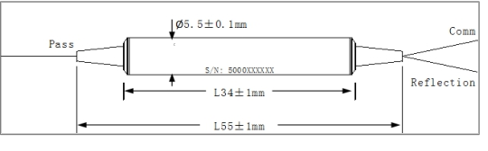

Ordering Information
DWDM- ①-②②②-③③③-④④-⑤⑤⑤-⑥-⑦-⑧⑧

① | Type | M=Mux; D=Demux;
② | Channel Space | 0.5=50GHz;
③ | Channel Type | 1ch;
④ | ITU Channel | 21=21ch; 21*=21*ch; 22=22ch; 22*=22*ch; ……; 59*=59*ch;
⑤ | Pigtail Type | 250=250um Fiber; 900=900um Loose Tube; 3mm=3mm Loose Tube;
⑥ | Fiber Type | 1=SMF-28e;
⑦ | Fiber Length | 1=1m;
⑧ | Connector | NE=None; FA=FC/APC; FC=FC/UPC; SA=SC/APC; SC=SC/UPC; LC=LC/UPC; XX=Others;
_____________________________
Tel: +86 755 86197637 www.htopto.com sales@htopto.com

