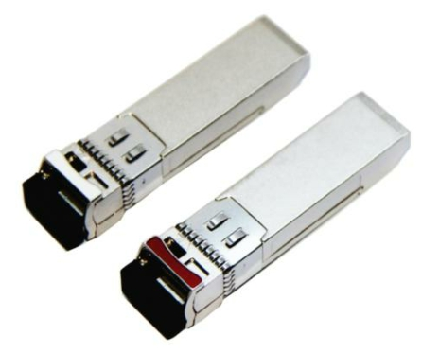

HT204-4955S80D/ HT204-5549S80D

RoHS Compliant 10Gb/s SFP+ BiDi 80km Optical Transceiver
TX1490nm/RX1550nm,TX1550nm/RX1490nm

PRODUCT FEATURES

 SFP MSA package with single LC connector
 Typical bidi 1490/1550nm and 1550nm/1490nm for commission
 APD receiver for high sensitivity
 Very low EMI and excellent ESD protection
 Digital Diagnostic Monitor Interface
 Hot pluggable
 Support 9.95Gb/s to 11.1Gb/s serial optical interface
 Up to 80km distance
 Compliant with SFP+ MSA
 High transmission margin
 +3.3V single power supply
 Below <1.5W power consumption

APPLICATIONS

 10GBASE-BX at 10.3125 Gb/s
 Other optical link STANDARD
 SFP+ MSA Compliant
 SFF-8472 reversion 9.5 compliant
 IEEE802.3-2005 compliant
 Telcordia GR-468-CORE compliant
 FCC 47 CFR Part 15,Class B compliant
 FDA 21 CFR 1040.10 and 1040.11,class1 compliant
 RoHS compliant

PRODUCT DESCRIPTIONS

HT204-4955S80D/HT204-5549S80D is hot pluggable 3.3V Small-Form-Factor transceiver module. It designed expressly for high-speed communication applications that require rates up to 11.1Gbps,it designed to be compliant with SFF-8472 and SFP+ MSA. The module data link up to 80km in 9/125um single mode fiber. The optical output can be disabled by a LVTTL logic high-level input of Tx Disable. Tx Fault is provided to indicate that degradation of the laser. Loss of signal (LOS) output is provided to indicate the loss of an input optical signal of receiver or the link status with partner.

H&T Proprietary and Confidential

Page 1 of 6 V1.3

ABSOLUTE MAXIMUM RATINGS

Parameter | Symbol | Min. | Max. | Unit | Note
Supply Voltage | Vcc | -0.5 | 4.0 | V
Storage Temperature |  | -40 | 85 | °C
Relative Humidity |  |  | 85 | %
Note: Stress in excess of the maximum absolute ratings can cause permanent damage to the module

GERERAL OPERATING CHARACTERISTICS

Parameter |  | Symbol | Min. | Typ | Max. | Unit | Note
Data Rate | Ethernet |  |  | 10.3125 |  | Gb/s
 | Fiber Channel |  |  | 9.953
Supply Voltage |  | Vcc | 3.13 | 3.3 | 3.47 | V
Supply Current |  | Icc5 |  |  | 500 | mA
Operating Case Temp. |  | Tc | 0 |  | 70 | °C

ELECTRICAL INPUT/OUTPUT CHARACTERISTICS

 Transmitter

Parameter |  | Symbol | Min. | Typ | Max. | Unit | Note
Diff. input voltage swing |  |  | 120 |  | 820 | mVpp | 1
Tx Disable input | H | VIH | 2.0 |  | Vcc+0.3 | V
 | L | VIL | 0 |  | 0.8
Tx Fault output | H | VOH | 2.0 |  | Vcc+0.3 | V | 2
 | L | VOL | 0 |  | 0.8
Input Diff. Impedance |  | Zin |  | 100 |  | Ω

 Receiver

Parameter |  | Symbol | Min. | Typ | Max. | Unit | Note
Diff. output voltage swing |  |  | 340 | 650 | 800 | mVpp | 3
Rx LOS Output | H | VOH | 2.0 |  | Vcc+0.3 | V | 2
 | L | VOL | 0 |  | 0.8
Note 1) TD+/- are internally AC coupled with 100Ω differential termination inside the module.

Note 2) Tx Fault and Rx LOS are open collector outputs, which should be pulled up with 4.7k to 10kΩ resistors on the host board. Pull up voltage between 2.0V and Vcc+0.3V.
Note 3) RD+/- outputs are internally AC coupled, and should be terminated with 100Ω (differential) at the user SERDES.

H&T Proprietary and Confidential

Page 2 of 6 V1.3

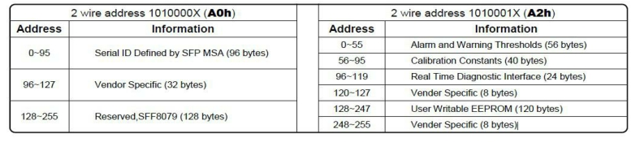

OPTICAL CHARACTERISTICS

 Transmitter (10.3125Gb/s)

Parameter | Symbol | Min. | Typ | Max. | Unit | Note
Operating Wavelength |  |  | 1490/1550 |  | nm | 1
Ave. output power (Enabled) | Po | 0 |  | +6 | dBm | 2
Extinction Ratio | ER | 5 |  |  | dB | 2
RMS spectral width | Δλ |  |  | 1 | nm
Rise/Fall time (20%~80%) | Tr/Tf |  |  | 50 | ps | 3
Optical modulation amplitude | OMA | -4.8 |  |  | dBm
Dispersion penalty |  |  |  | 3 | dB
Output Optical Eye | IEEE 802.3-2005 Compliant

 Receiver (10.3125Gb/s)

Parameter | Symbol | Min. | Typ | Max. | Unit | Note
Operating Wavelength |  |  | 1550/1490 |  | nm | 1
Sensitivity | Psen |  |  | -21 | dBm | 4
Min. overload | Pimax | -7 |  |  | dBm
LOS Assert | Pa | -40 |  |  | dBm
LOS De-assert | Pd |  |  | -22 | dBm
LOS Hysteresis | Pd-Pa | 0.5 |  | 4 | dB
Note 1) TX1490nm/RX1550nm,TX1550nm/RX1490nm.

Note 2) Measured at 10.3125b/s with PRBS 231 – 1 NRZ test pattern.
Note 3) 20%~80%
Note 4) Under the ER worst case, measured at 10.3125 Gb/s with PRBS 231 - 1 NRZ test pattern for BER < 1x10-12

SERIAL INTERFACE FOR ID AND DDM

● Serial Interface for ID and DDM
The SFP modules implement the 2-wire serial communication protocol as defined in the SFP MSA.
The serial ID information of the SFP modules and Digital Diagnostic Monitor parameters can be accessed through the I2C interface at address A0h and A2h. The memory is mapped in Table 1. Detailed ID information(A0h) And the DDM specification(A2h). For more details of the memory map and byte definitions, please refer to the SFF-8472 (Rev 9.3, Aug. 2002), “Digital Diagnostic Monitoring Interface for Optical Transceivers”.
The DDM parameters have been internally calibrated.

Table 1. Digital Diagnostic Memory Map (Specific Data Field Descriptions)

H&T Proprietary and Confidential

Page 3 of 6 V1.3

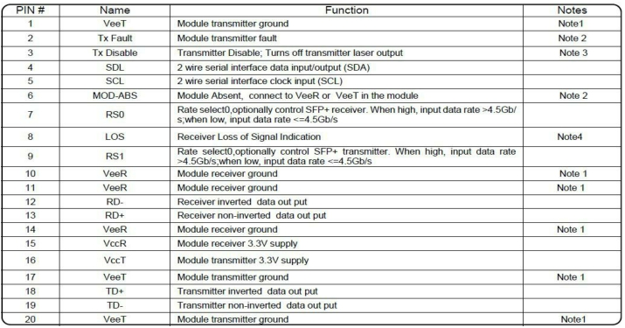
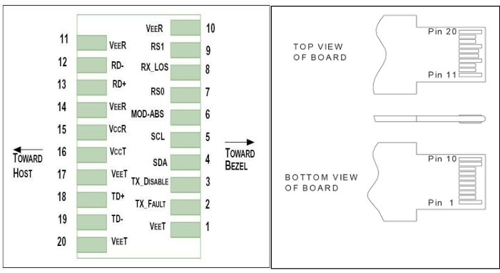

PIN DEFINITIONS AND FUNCTIONS

Note 1) The module ground pins shall be isolated from the module case.
Note 2) This pin is an open collector/drain output pin and shall be pulled up with 4.7K-10Kohms to Host_Vcc on the host board. Note 3) This pin shall be pulled up with 4.7K-10Kohms to VccT in the module.
Note 4) This pin is an open collector/drain output pin and shall be pulled up with 4.7K-10Kohms to Host_Vcc on the host board. In FC designated as RX_LOS, inSONET designated as LOS, and in Ethernet designated at Signal Detect.

H&T Proprietary and Confidential

Page 4 of 6 V1.3

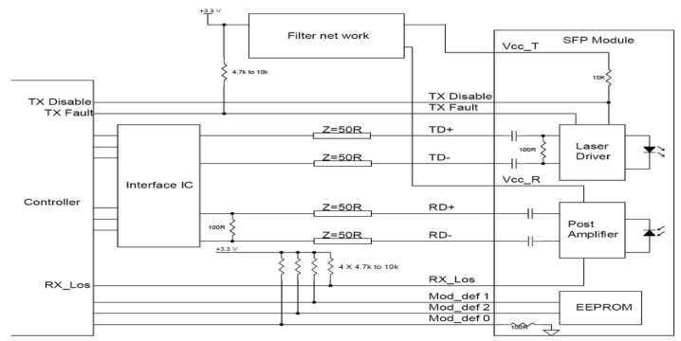
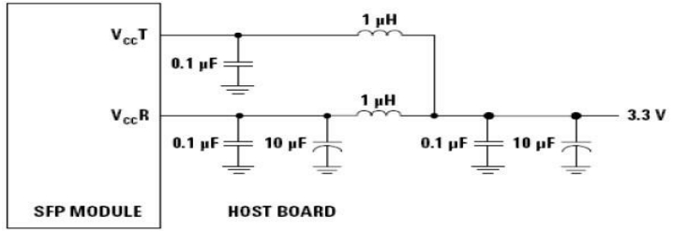

TYPICAL INTERFACE CIRCUIT

Recommended power supply filter

Note: Inductors with DC resistance of less than 1Ω should be used in order to maintain the required voltage at the SFP input pin with 3.3V supply
voltage. When the recommended supply filtering network is used, hot plugging of the SFP transceiver module will result in an inrush current of no more than 30 mA greater than the steady state value

H&T Proprietary and Confidential

Page 5 of 6 V1.3

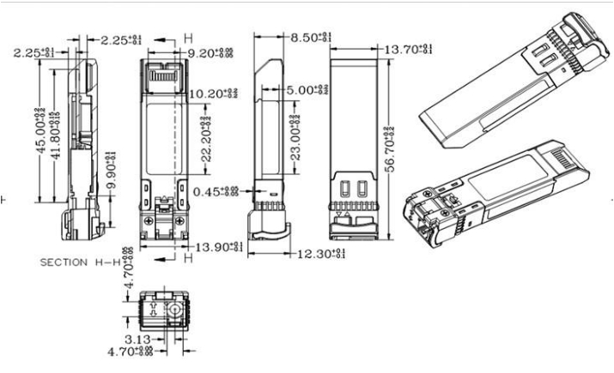

PACKAGE DIMENSIONS

ORDERING INFORMATION

Part Number | Description
HT204-4955S80D | SFP+ Plus BiDi,T1490/R1550,10.3125Gbps, 80KM,0~70℃, with DDM
HT204-5549S80D | SFP+ Plus BiDi,T1550/R1490,10.3125Gbps, 80KM,0~70℃, with DDM

H&T Proprietary and Confidential
Page 6 of 6

V1.3

