1GE PON PORT GPON ONT
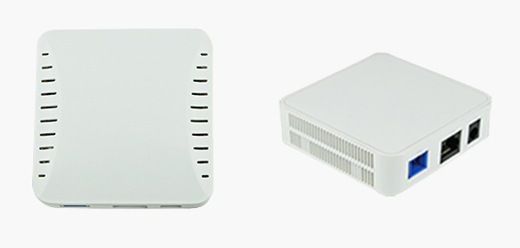
Overview
1GE PON Port HT3400G GPON ONT is one of the GPON optical network unit design to meet the requirement of the broadband access network. It is widely applied in FTTH/FTTO to provide the data and video service based on the GPON network.

GPON is the latest generations of access network technology. ITU-T G.984 is the standard protocol of GPON. The GPON standard differs from other PON standards in that it achieves higher bandwidth and higher efficiency using larger, variable-length packets. GPON offers efficient packaging of user traffic, with frame segmentation allowing higher quality of service (QOS) for delay-sensitive voice and video communications traffic. GPON networks provides the reliability and performance expected for business services and provides an attractive way to deliver residential services. GPON enables Fiber To The Home (FTTH) deployments economically resulting to accelerated growth worldwide.
HT3400G is based on ZTE high-performance xPON access chip. The chip supposes three mode：GPON/EPON/P2P, comply with the GPON standard of g.984, g.983, 802.3-2005, CTC EPON equipment technical requirements, have good xPON interoperability compatibility.
HT3400G provide one GE auto-adapting Ethernet ports. The HT3400G features high-performance forwarding capabilities to ensure excellent experience with Internet and HD video services. Therefore, the HT3400G provides a perfect terminal solution and future-oriented service supporting capabilities for FTTH deployment. It has good third-party compatibility to work with the third party OLT, such as Huawei/ZTE/Fiberhome/Alcatel·Lucent.

Features
Fully compatible with ITU-T G.984.1/2/3/4
Support downlink rate 2.448Gbit/s, uplink rate is 1.244Gbit/s
Support 32 TCONT, 256 GEMPORT
Support bidirectional FEC, supports the RS (255, 239) FEC decoding
Support AES128 encryption and decryption functions with G.984 standard
Support SBA and DBA bandwidth allocation
Support PLOAM, embedded OMCI management with G.984 standard
Support Dying-Gas detection and reporting
Support rogue ONU detection
Support GPON energy saving of G987.3 protocol
Support Tag/Untag Ethernet frame of 802.1 and Q 802.3 standard, support QinQ
Support CTC2.1, TR156 requirements of flexible tag processing
Support for flexible flow classification, maximum 520 flow classification rules
Support link error monitoring and loop monitoring
Support a variety of multicast forwarding mode, support multicast replication
Auto-negotiation and manual settings of Ethernet supporting rate, duplex mode
UNI interface supports STP/RSTP protocol
Provide QoS guarantees for different priority business through SLA restraining, Policing, queue management scheduling / congestion avoidance, discarding management mode
Support flow control based on entrance , choose Pause frame reaction pressure to Packet loss for the business beyond
Support HQoS function
Technical specifications
Item | Parameters | Specification
Interface | PON Port | 1*GPON port, FSAN G.984.2 standard, Class B+  Downstream Data Rate：2.488Gbps  Upstream Data Rate：1.244Gbps  SC/PC single mode fiber  28dB Link loss and 20KM distance with 1:128
 | Ethernet Port(LAN) | 1*GE Auto-negotiation RJ45 ports  Full Duplex / Half-Duplex  RJ45, Auto-MDI/MDI-X  Transmission Distance 100 Meter
 | Power Supply Port | 12V DC input
Management | Network Management | Standard compliant OMCI interface as defined by ITU-T  G.984.4  Support WEB management
 | Management function | Status monitor, Configuration management, Alarm management, Log management
Physical | Shell | Plastic casing
 | Power | External 12V 0.5A AC/DC power supply adapter
 | Power consumption | <3W
 | Dimensions | 78mm(L) x78mm(W) x25mm (H)
 | Weight | 0.1kgs
Environmental | Environment | Operating Temperature：0～50℃  Storage Temperature：-40～85℃  Operating Humidity：10%～90%(Non-condensing)  Storage Humidity：5%～95%(Non-condensing)
Warranty |  | One year

Typical application
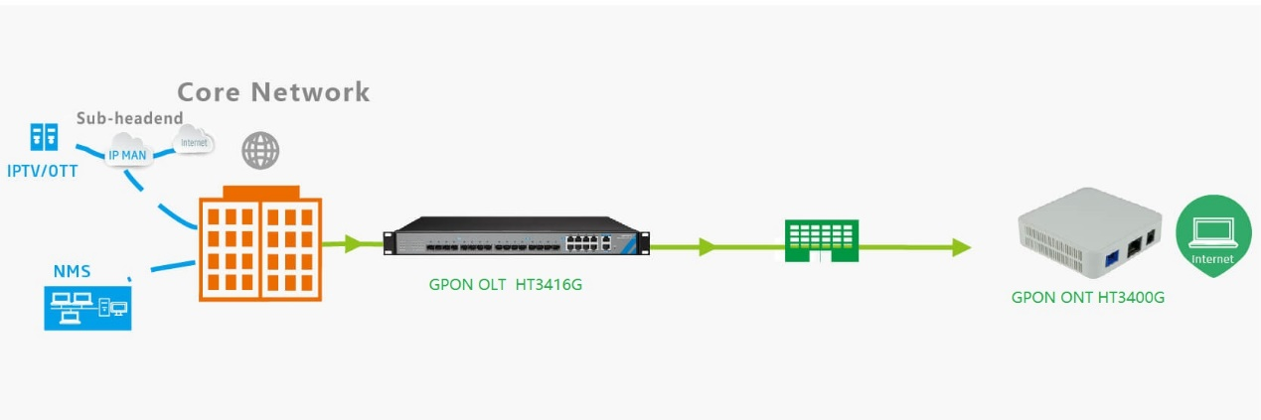

Ordering information
Product Name | Product Model | Product description
SFU Type GPON ONU | HT3400G GPON | 1*GE Ethernet interface, 1 GPON interface, plastic casing, external power supply adapter

