1GE+1FE+1POTS+Dual band WIFI GPON ONT
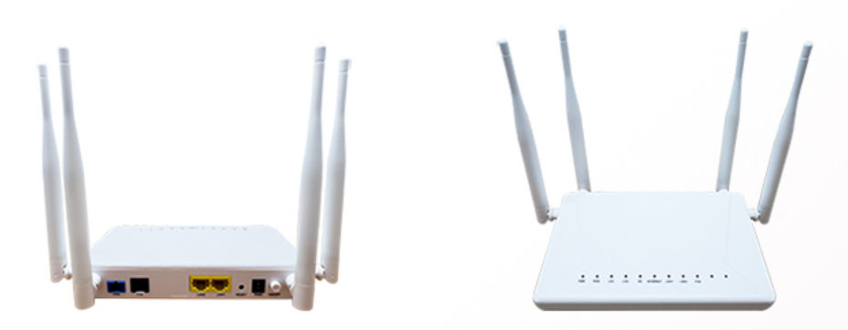
HT3421GWV-D FTTH GPON ONT Overview
By introducing latest fiber GPON access technology, The HT3421GWV-D GPON ONU brings carrier class high-end networking solution for advanced triple play services. It compliant with ITU-T G.984 standard, dual-band wireless for combined connection speeds of up to 1200 Mbps(867 Mbps on 5GHz and 300 Mbps on 2.4 GHz) , Layer 2/3, and high quality VoIP, It adopts single fiber WDM technology with downlink wavelength 1490nm, uplink wavelength 1310nm, HT3421GWV-D FTTH GPON ONU WiFi support the comprehensive triple-play services, including voice, video (IPTV or VoD), and high-speed internet access service.

Key Feature
Features | RL841GWV-D
GPON Features | Compliant with ITU-T G.984 GPON standard
 | FEC (Forward Error Correction) in both upstream and downstream
 | QoS scheduling based on SP or WRR between GEM port and T-CONT
 | Downstream multicast GEM port and broadcast GEM port
Ethernet Feature | Support Auto-speed and MDI/MDIX auto detection
 | Internal L2 switch
 | Advanced data processing function,such as VLAN label processing, flow classification
Gateway Feature | WAN support Router and Bridge mode
 | Router mode supports PPPoE/DHCP/ static IP
 | WAN support Internet、VoIP、IPTV、TR069
 | LAN supports DHCP and static IP
 | Support NAT and NAPT
VoIP Feature | Support SIP (RFC3261) or MEGACO v2 (H.248)
 | Support Voice coding: ITU-T G.711/G.723/G.726/G.729, auto-negotiate with call agent
 | Support Echo cancellation exceeding ITU-T G.165/G.168-2002, up to 128ms tail length
WIFI Feature | 867 Mbps on 5GHz and 300 Mbps on 2.4 GHz
 | IEEE 802.11 ac/n/g/b/a wireless LAN
 | 2.4 GHz band: 2400 – 2483.5 MHz,5 GHz band: 5150 – 5725 MHz
 | WEP、WPA-PSK、WPA2-PSK and other encryption
OAM Feature | Standard OMCI (the embedded operations channel)compliant with ITU-T G.988
 | Compliant with TR-069 standard
 | Compliant with TR-098、TR-140 terminal integrated management interface
 | Alarm reporting, performance monitoring

Technical specifications
GPON Interface
Rate | Upsteam: 1.244Gbps Downsteam: 2.488Gbps
Interface standard | ITU-T G.984.2/ITU-T G.984.3/ITU-TG.988 Class B+
Launch power | Min: 0dBm Max: +5dBm
Sensitivity | -27dBm
Input Power Overload | -8dBm
Service Interface
GPON Interface | 1 GPON Port
Data Interface | 1 GE + 1FE
POTS Interface | 1 FXS Port
WIFI Interface | IEEE 802.11 ac/n/g/b/a wireless LAN
Antenna Type | 4 external antennas
Environmental conditions
Storage | temperature -10 to 70°C, rel. humidity 10–90% (non-condensing)
Operation | temperature 0 to 45°C, rel. humidity 10–90% (non-condensing)
Power Supply and Consumption
Power Adaptor | Input: 100 to 240 V AC, 50/60 Hz; Output: 12 V, 1A
Consumption | ≤10W
Physical specifications
Dimensions | 236mm×210mm×31mm（L×W×H）
Weight | 0.26KG

Typical application
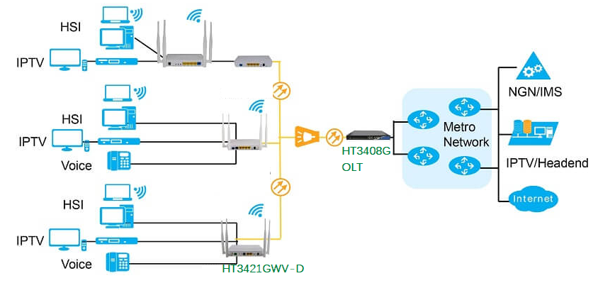

Ordering information
Model | Product Description
HT3421GWV-D | GPON ONU 1GE+1FE+1POTS+11n 2*2 +11ac 2*2, 4 x External Antennas 5DBI

