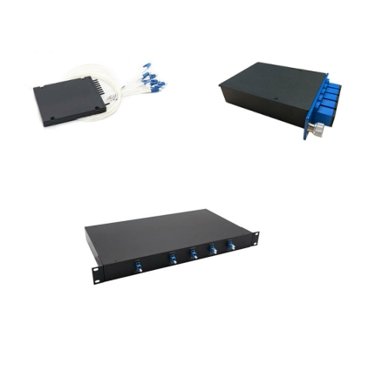

Data Sheet

Optical Interconnection Innovator

Dense Wavelength Division Multiplexer &

DeMultiplexer (DWDM Mux DeMux)

Features

✓ Low Insertion Loss (IL)

✓ High isolation

✓ Low Polarization Dependent Loss (PDL)

✓ Available in 2 to 32 channels with compact design

✓ Good channel-to-channel uniformity

✓ Wide operating wavelength range

✓ High reliability and high stability

✓ Telcordia GR-1209-CORE-2001 compliant

✓ Telcordia GR-1221-CORE-1999 compliant

✓ ITU-T G.694.1 compliant

✓ RoHS-6 compliant (lead free)

Applications

✓ DWDM Networks

Description

The H&T Dense Wavelength Division Multiplexer &DeMultiplexer (DWDM Mux DeMux) is designed for ITU channel spacing applications. It is based on the Thin Film Filter (TFF) technology and operates at 100GHz or 200GHz channel spacing ITU Grid DWDM wavelengths from 1526nm to 1565nm. H&T provides a series of customized DWDM Mux DeMux within plastic ABS box, metal LGX box, or 19-inch 1U rack mount to meet different requirements on Port Configuration (2 to 32 channels, 1310nm/upgrade/monitoring ports available), Operating Wavelength, Package Type, Fiber Type, Fiber Length, Input Connector, and Output Connector.

Specifications

Parameters | Channel Options
Port Configuration | 1x2 | 1x4 | 1x8 | 1x16
Center Wavelength (nm) | ITU Grid
Operating Wavelength (nm) | 1520 to 1620
Channel Space (nm) | 0.8
Passband @0.5dB (nm) | 0.22
Channels IL (dB) | < 1.5 | < 1.8 | < 2.6 | < 4.2
Link IL (Mux+Demux) (dB) | < 2.7 | < 3.0 | < 3.8 | < 5.4
Adjacent Channels Isolation (dB) | > 30
Non-Adjacent Isolation (dB) | > 45
Directivity (dB) | > 50
Return Loss (dB) | > 45
Ripple (dB) | < 0.5
PDL (dB) | < 0.2
PMD (ps) | < 0.1

Email: sales@htopto.com Website: www.htopto.com

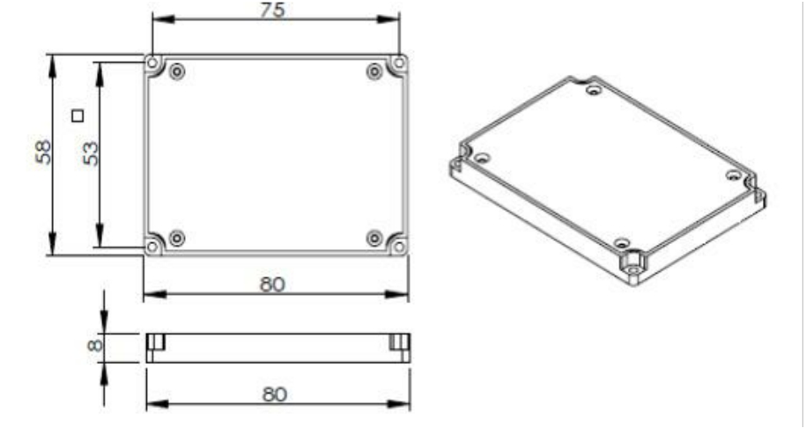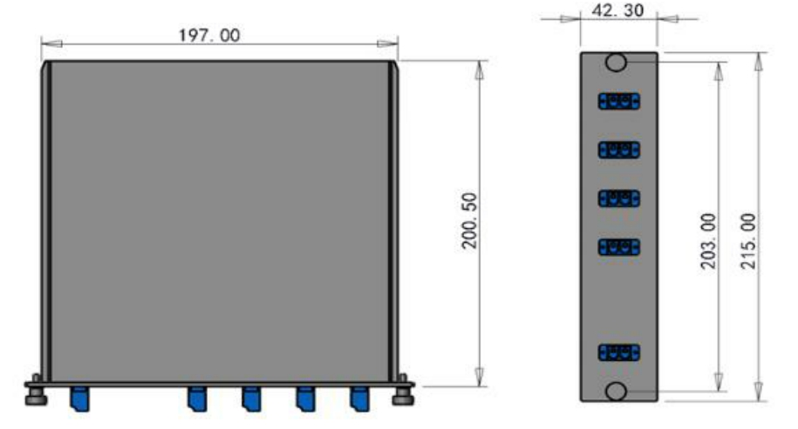

Data Sheet

Optical Interconnection Innovator

Maximum Optical Power (mw) | 300
Operating Temperature (℃) | -5 to +75
Storage Temperature (℃) | -40 to +85
Package (mm) (L×W×H) | ABS Box: 80×58×8, 100×80×10, 120×80×18, 140×115×18  LGX Box: standard, 2 in 1, 4 in 1  19-inch 1U Rack Mount: standard

Notes:
1. All specifications are based on the devices with connectors, and guaranteed over wavelength and temperature.
2. Fiber type is G657A1.
3. An additional 0.3dB loss ought to be added per adapter for LGX box and rack mount.

Mechanical Dimensions

ABS Box (PX: 80×58×8):

LGX Box (2 in 1):

Email: sales@htopto.com Website: www.htopto.com

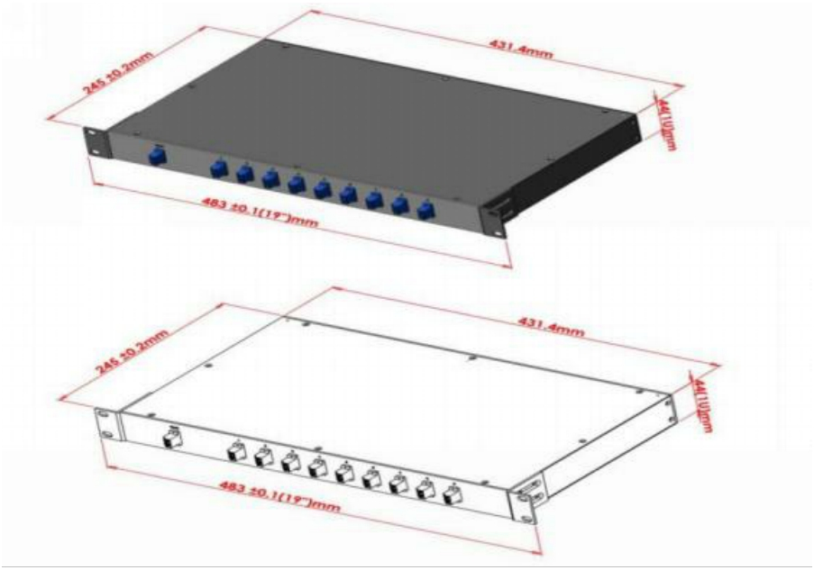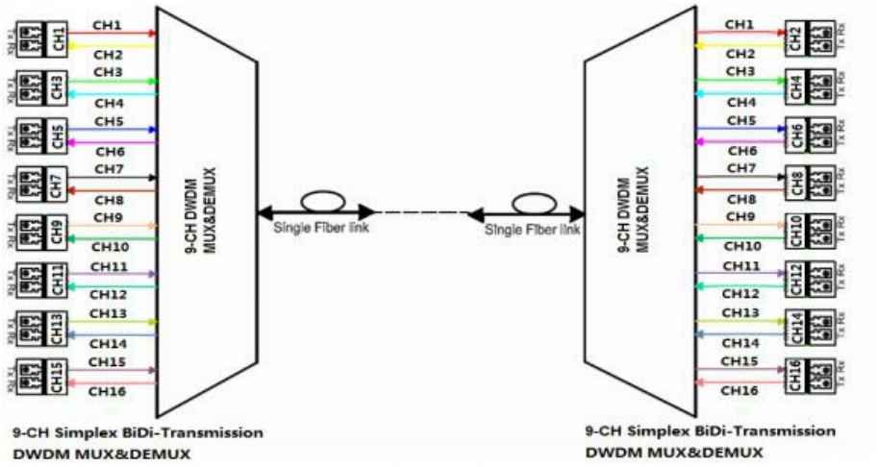

Data Sheet

Optical Interconnection Innovator

19-inch 1U Rack Mount:

Structure Diagram

Email: sales@htopto.com Website: www.htopto.com

Data Sheet

Optical Interconnection Innovator

Ordering Information

HTDWM-xx | x | x | xx | xx | x | xx- | x | x
Channel  Options  xx: 02=2CH 04=4CH 08=8CH 16=16CH  ...  32=32CH | Channel  Space | MUX/DEMUX  Type | Initial  Wavelength | Package Type | Fiber Type | Fiber  Length | Input  Connector | Output  Connector
 | X=100GHz | M=MUX | 15=15CH | PX=80×58×8  ABS Box | B=250um  bare fiber | 10=1.0m | 0=None | 0=None
 | Y=200GHz | D=DEMUX | 16=16CH | PS=100×80×10  ABS Box | 09=0.9mm  loose tube | 15=1.5m | 1=FC/UPC | 1=FC/UPC
 |  | 1=MUX  with 1310nm port | 17=17CH | PM=120×80×18  ABS Box | 20=2.0mm  loose tube | 20=2.0m | 2=FC/APC | 2=FC/APC
 |  | 2=DEMUX  with 1310nm port | ... | PL=140×115×18  ABS Box |  | 25=2.5m | 3=SC/UPC | 3=SC/UPC
 |  | 3=MUX  with UPG port | 59=59CH | LX=Standard  LGX Box |  | ... | 4=SC/APC | 4=SC/APC
 |  | 4=DEMUX  with UPG port | 60=60CH | 21=2 in 1 LGX Box |  |  | 5=LC/UPC | 5=LC/UPC
 |  | 5=MUX  with 1310nm &  UPG ports | 61=61CH | 41=4 in 1 LGX Box |  |  | 6=LC/APC | 6=LC/APC
 |  | 6=DEMUX  with 1310nm &  UPG ports | 62=62CH | 19=19-in 1U  Rack Mount
 |  | 7=MUX  with 1310nm &  MON ports | 63=63CH
 |  | 8=DEMUX  with 1310nm &  MON ports | 64=64CH

Notes:
If there is a demand for orders that are different from those described above, please contact Htopto sales.

E-mail: sales@htopto.com Website: www.htopto.com

Email: sales@htopto.com Website: www.htopto.com

